TEST REPORT

For

*E-Learning course and apps development of Light Engineering Sector for BTEB*

Ref: SD-38

Submitted By

~

Olivine Limited

Innovative Ideas Led by Adroit

VERSION HISTORY

| **Version #** | **Implemented**  **By** | **Revision**  **Date** | **Approved**  **By** | **Approval**  **Date** | **Reason** |
| --- | --- | --- | --- | --- | --- |
| 1.0 | Hridoy | 01/01/22 | Mohammad Samawat Ullah | 20/01/22 | Unit Testing Done |
| 2.0 | Hridoy | 01/02/22 | Mohammad Samawat Ullah | 26/02/22 | UAT |
|  |  |  |  |  |  |
|  |  |  |  |  |  |

# 

**Table of Contents**

| **1.0** | **Purpose** | 4 |
| --- | --- | --- |
| **2.0** | **Test Summary** |  |
|  | 2.1 Unit Test | 4 |
|  | 2.2 Test Type (Function, Unit, System, etc.) | 4 |
| **3.0** | **Test Assessment** | 5 |
| **4.0** | **Test Results** |  |
|  | 4.1 Unit/ Module/ System Testing | 5 |
|  | 4.2 User Acceptance Testing | 14 |
| **5.0** | **Variances** | 15 |
| **6.0** | **Test Instances** |  |
|  | 6.1 Resolved Test Incidents | 15 |
|  | 6.2 Unresolved Test Incidents | 15 |
| **7.0** | **Recommendations** | 16 |
|  | **Appendix A: Test Report Approval** | 17 |
|  | **Appendix B: References** | 18 |

# 

# 

# 

# 

# 1.0 INTRODUCTION

## 1.1 PURPOSE

This ‘game app.com.bd‘ website Test Report provides a summary of the results of a test performed as outlined within this document.

# 2.0 TEST SUMMARY

The test report summarized a robust brute force test to check overall functionalities, including unit test, UAT etc. in the unit test part we have tested all functionalities that were supposed to act as mentioned in the GDD and according to the design plan. However, UAT mainly focuses on end-user acceptance and focuses on design fixes, working environment and better user experiences.

**Project Name**: Skill Development for Mobile Game and Application

**System Name**: E-Light Engineering

**Version Number**: 2.0

**Additional Comments**: N/A

## 2.1 unit test

We have planned and categorized Unit Testing Techniques mainly into three parts which are Black box testing that involves testing of user interface along with input and output, White box testing that involves testing the functional behavior of the software application and grey box testing that is used to execute test suites, test methods, test cases and performing risk analysis.

Code coverage techniques used in Unit Testing are listed below:

* Statement Coverage
* Decision Coverage
* Branch Coverage
* Condition Coverage
* Finite State Machine Coverage

**Test Owner**: Hridoy Chandra Deb

**Test Date**: 01/01/22- 26/02/22

**Test Results**: Most of the test cases passed through except a few exceptions that were reported back for further development and fix. Moreover, fixed cases were tested in version-2 for final approval.

## 2.2 TEST TYPE (FUNCTION, UNIT, SYSTEM, ETC.)

At this stage of UAT, we initially Prepare UAT plan in the project life cycle. After that, a Checklist is prepared before the UAT starts. Besides, the Pre-UAT session is conducted during the System Testing phase itself. Once the previous stage passed, we set the expectation and define the scope of UAT clearly. Finally, we test End to End business flow and avoid system tests. The following checklist's purpose is to ensure that the appropriate steps have been taken to execute a user acceptance test (UAT), to wrap up the process and ensure proper documentation has been completed. We choose "Yes, No or N/A" as it applies to the UAT process in the organization.

1. Review and analyze business and functional requirements.
2. Create test cases.
3. Run standard test cases and associated ad-hoc tests relevant to usability and acceptance criteria.
4. Log and report defects
5. Log and report usability comments, issues, or suggestions
6. Discuss defects and/or issues with your team.
7. Retest after any changes

# 3.0 TEST ASSESSMENT

For the Unit test and UAT to be effective, we have seen it as validation instead of verification. We considered this UAT in both large and small contexts. In the large context, test scenarios are an excellent way to simulate real-world processes. In the smaller context, test cases and/or test procedures are suitable for users to validate smaller scope functionality.

# 4.0 TEST RESULTS

The test results are listed below with a detailed explanation. Each case are based on a business requirement and use case and tested by both developer end (unit test) and end-user end (UAT) with a comment of being passed/failed

## UNIT/MODULE/SYSTEM TESTING

* **Test Case ID: 1**

Description: This function meets the expected result. show user name or criteria in dashboard launch the web successfully.

Pass / Fail: Pass.

Test Case:

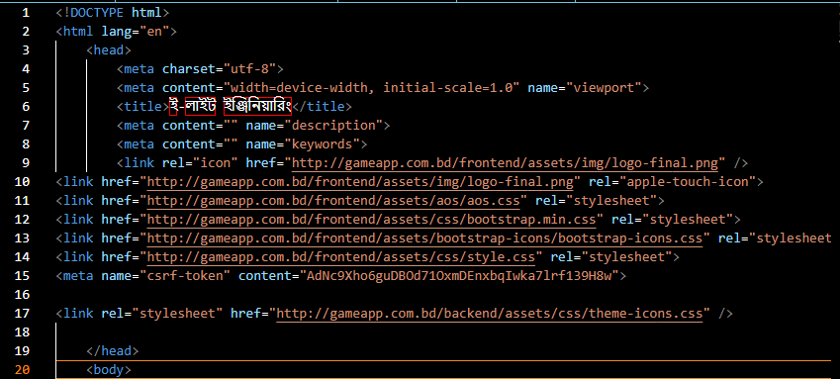

* **Test Case ID: 2**

Description: To test whether the NTVQF curriculum course shows properly

Pass / Fail: Pass.

Test Case:

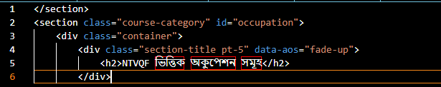

* **Test Case ID: 3**

Description: To test whether the NTVQF curriculum course shows details.

pass / Fail: Pass.

Test Case:

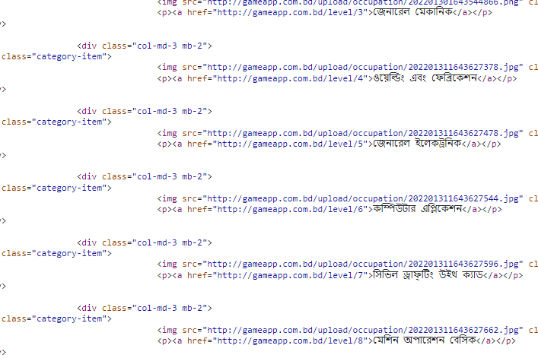

* **Test Case ID:4**

Description: To test whether a click on the footer link works properly.

Pass / Fail: Pass

Test Case:

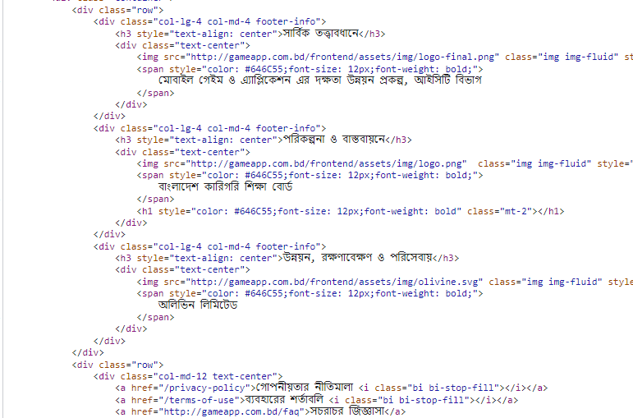

* **Test Case ID:5**

Description: To test where teacher login function works properly or not.

Pass / Fail: Pass

Test Case:

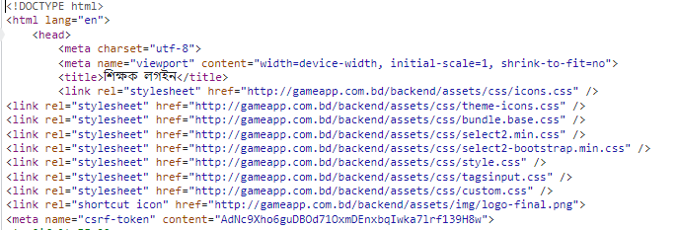

* **Test Case ID:6**

Description: To test where student login function works properly or not.

Pass / Fail: Pass

Test Case:

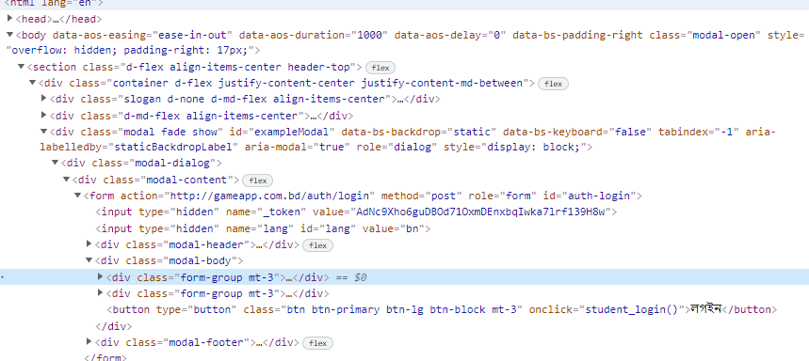

**Test Case ID:7**

Description: To check where the registration module takes input from the user correctly.

Pass / Fail: Pass

Test Case:

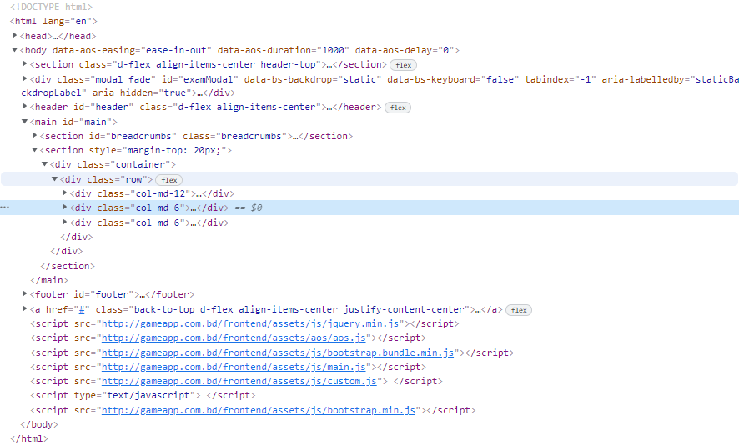

* **Test Case ID:8**

Description: The student login dashboard shows properly.

Pass / Fail: Pass

Test Case:

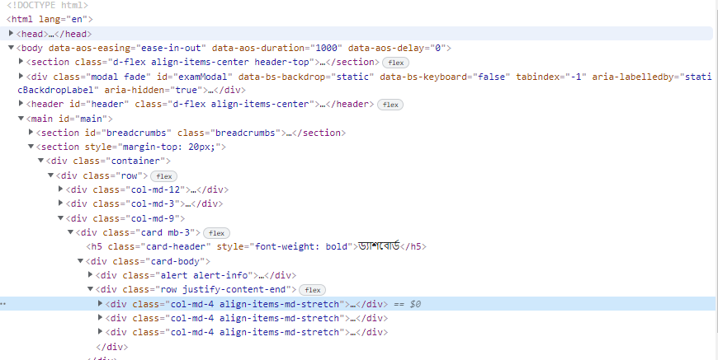

**Test Case ID:9**

Description: To check after the login where student Profile management and data change works properly.

Pass / Fail: Pass

Test Case:

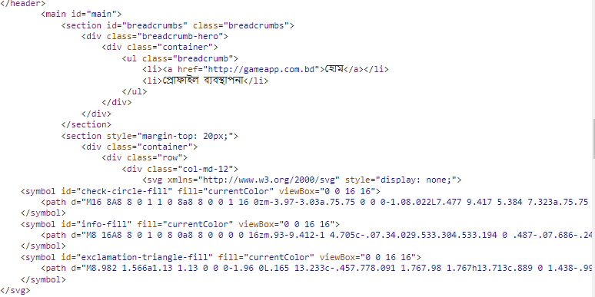

* **Test Case ID:10**

Description: To check after the login where students password change correctly. These functions worked fine.

Pass / Fail: Pass

Test Case:

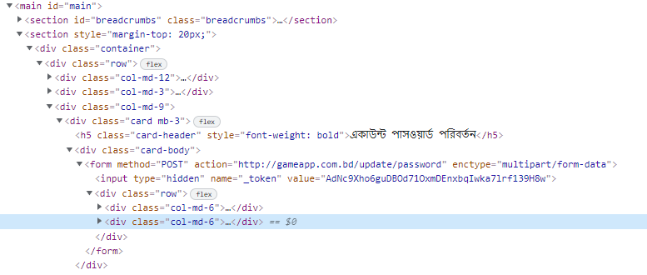

**Test Case ID:11**

Description: To check whether a student can show his or her quiz result.

Pass / Fail: fail

Test Case:

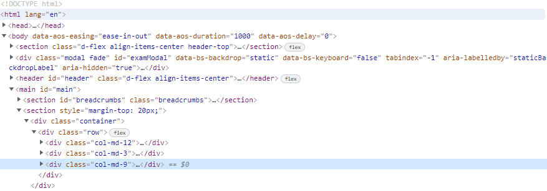

* **Test Case ID:12**

Description: In Teacher login dashboard shows properly.

Pass / Fail: Pass

Test Case:

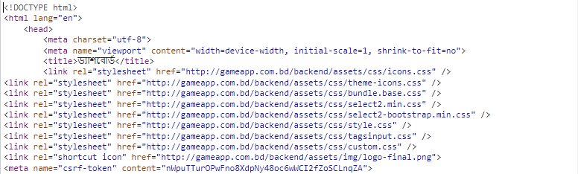

* **Test Case ID:13**

Description: To check after the login in account setting where teachers can change the password correctly and data add or delete correctly. These functions worked fine.

Pass / Fail: Pass

Test Case:

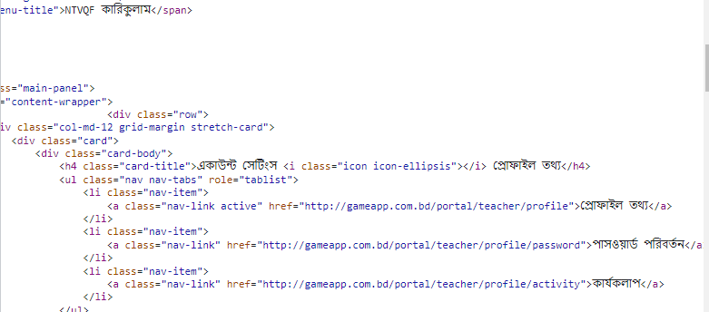

* **Test Case ID:14**

Description: To check after the login in NTVQF curriculum where teacher can add, delete and modify curriculum correctly. These functions worked fine.

Pass / Fail: Pass

Test Case:

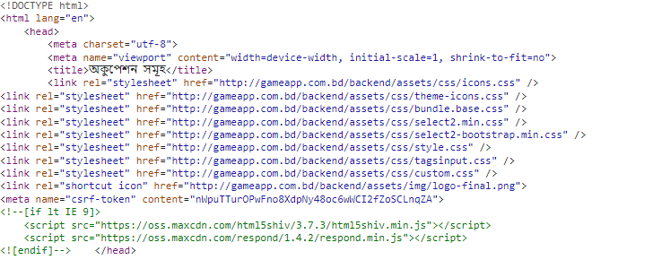

# 4.2 USER ACCEPTANCE TESTING

The table below summarizes the test cases employed for user acceptance testing and the test results obtained for each test case:

| Serial No: | Test Case ID | Test Case | Tester | Pass/Fail | Severity of Defect | Summary of Defect | Comments |
| --- | --- | --- | --- | --- | --- | --- | --- |
|  | 001 | Entering successfully to the web. | Hridoy | Pass | N/A |  |  |
|  | 002 | User is able to access the home curriculum | Hridoy | Pass | N/A |  |  |
|  | 003 | Users are able to see curriculum details. | Hridoy | Pass | N/A |  |  |
|  | 004 | Footer social links on the web do not work. | Hridoy | Fail | Fail |  |  |
|  | 005 | Click back to the drop down button. | Hridoy | Pass | N/A |  |  |
|  | 006 | Image resolution Problem | Hridoy | pass | N/A |  |  |
|  | 007 | When tried to input the quiz question and answer, error shoots. | Hridoy | pass | N/A |  |  |
|  | 008 | Does not take Bangla numerical input | Hridoy | pass | N/A |  |  |
|  | 009 | Does not show the pdf file in curriculum | Hridoy | pass | N/A |  |  |
|  | 010 | Not responsive with profile image size | Hridoy | Pass | N/A |  |  |
|  | 011 | profile image not merged in round shape. | Hridoy | Pass | N/A |  |  |
|  | 012 | change the password, not be able to login with the new password. | Hridoy | Pass | N/A |  |  |
|  | 013 | search in Bengali, you will not find data. | Hridoy | Pass | N/A |  |  |

# 5.0 VARIANCES

variances between the testing that was planned and the testing that actually occurred. Also, provide an assessment of the manner in which the test environment may be different from the operational environment and the effect of this difference on the test results.]

# 6.0 TEST INSTANCES

Provide a brief description of the unexpected results, problems, or defects that occurred during the testing.

## RESOLVED TEST INCIDENTS

Identify all resolved test incidents and summarize their resolutions. Reference may be made to Test Incident Reports that describe in detail the unexpected results, problems, or defects reported during testing, along with their documented resolutions, which may be included as an appendix to this document.

## UNRESOLVED TEST INCIDENTS

Identify all unresolved test incidents and provide a plan of action for their resolution. Reference may be made to Test Incident Reports that describe in detail the unexpected results, problems, or defects reported during testing, which may be included as an appendix to this document.

# 7.0 RECOMMENDATIONS

what actions are suggested upon completion of this test. Provide any recommended improvements in the design, operation, or future testing of the business product that resulted from the testing being reported. A discussion of each recommendation and its impact on the business product may be provided. If there are no recommendations to report, then simply state as such.

**APPENDIX A: Test Report Approval**

The undersigned acknowledge they have reviewed the ‘**gameapp.com.bd’ web** **Test Report** and agree with the approach it presents. Changes to this **Test Report** will be coordinated with and approved by the undersigned or their designated representatives.

| Signature: | SD-Pomerul | Date: |  |
| --- | --- | --- | --- |
| Print Name: | Pomerul Islam |  |  |
| Title: |  |  |  |
| Role: | Project Manager |  |  |

**APPENDIX B: REFERENCES**

The following table summarizes the documents referenced in this document.

| **Document Name and Version** | **Description** | **Location** |
| --- | --- | --- |
| UAT Checklist | UAT checklist followed by testing team | Attached |

